Predicting One-Year Survival After Hospital Discharge: A Comparison of Cox Regression, Random Survival Forests, DeepSurv and Cox-Time
Oded Katz (211862693) · Diana Morgan (336472261)
Survival Analysis and Machine Learning — Final Course Project
Data and Decision Sciences, Technion — Spring 2026

1. Introduction
This project continues Project Assignments 1 and 2 on synthetic dataset 2. PA1 was exploratory: covariates, missing values, the survival outcome and censoring, and Kaplan–Meier curves. PA2 selected a Cox proportional hazards model, tested whether the change in BUN over the admission adds information beyond the discharge level, checked proportional hazards, and compared the Cox model with a log-normal AFT model. Both fitted to the full dataset and reported in-sample summaries, so neither estimated how well survival can be predicted for a patient the model has not seen.
Here the data are split 80/20. The PA2 Cox model is refitted on the training set, and a random survival forest (RSF), DeepSurv and Cox-Time are fitted on the same patients and covariates. The three relax different subsets of the Cox model's assumptions — linearity in the log hazard, additivity of covariate effects, and constant hazard ratios — so the comparison asks not only whether flexibility helps but which assumption, if any, is binding. All figures and tables follow Section 7.

2. Data and preprocessing
Each of the 3,961 rows of synthetic dataset 2 is a patient admitted with acute decompensated heart failure who left hospital alive, described by 25 covariates: demographics, nine comorbidity indicators, the admission and discharge laboratory panels, and the length of stay (Table 2).
The event is death from any cause and time is measured in months from discharge. Follow-up closes administratively at 36 months, so patients still alive are right-censored there. Of the 2,282 censored patients, 1,473 reach the cutoff and 809 are lost earlier, at a median of 16.5 months. Censoring is assumed independent of survival time given the covariates. Median follow-up is 25.6 months (IQR 8.8–36.0); by the one-year horizon used throughout, 947 deaths have occurred and 328 patients have been censored (Table 1).
Following PA1, missing continuous values were replaced by medians; no categorical covariate had missing values. Following PA2, the nine comorbidity indicators were replaced by comorbidity burden — their count, grouped 0–1 (reference), 2–3 and 4+ — and ΔBUN = BUN at discharge − BUN on admission was constructed. The cohort is old and comorbid: median age 76, 46.5% women, hypertension in 86.6% and ischaemic heart disease in 62.7%, with median BUN rising from 25 mg/dL on admission to 28 at discharge.

3. Brief recap of the previous analyses

3.1 Project Assignment 1
The overall Kaplan–Meier curve (Figure 1) falls to about 0.53 at 36 months, most steeply over the first few months; roughly three quarters of the cohort are alive at one year. Sex and diabetes do not separate the cohort (Figure A2): one-year survival is 0.770 against 0.733 by sex and 0.740 against 0.764 by diabetes. Age and discharge BUN, split at their medians, do (Figure 2): 0.661 above age 76 against 0.844 below, and 0.676 above 28 mg/dL against 0.810 below, with confidence bands clear of each other throughout.

3.2 Project Assignment 2
PA2 selected a Cox model on sex, age, comorbidity burden, length of stay, discharge BUN, discharge creatinine and GFR, BNP, white blood cells, sodium, RDW, platelets, bilirubin, potassium and ΔBUN (Table 3; in-sample concordance 0.694). Nine terms are significant: age at 1.044 per year, discharge BUN at 1.021 per mg/dL, RDW at 1.120 per unit and BNP at 1.0002 per pg/mL, with sodium, potassium and ΔBUN below 1. Sex, comorbidity burden, white blood cells, discharge creatinine, discharge GFR and platelets are not.
ΔBUN does add information beyond the discharge level: a likelihood-ratio test against the model without it gave 27.63 on 1 degree of freedom, p = 1.5 × 10⁻⁷, so it is retained throughout. A Schoenfeld residual test on a rank transform of time flagged two of sixteen terms — discharge BUN at 0.036 and length of stay at 0.048 — both marginally, so PA2 read the violations as mild.
A log-normal AFT model on the same covariates agreed on direction throughout. Its one-year predictions (Figure 3) are almost identical to the Cox model's for age, separate slightly for RDW, and differ most for discharge BUN, where the AFT curve falls faster in mid-range and then crosses above in the tail. That figure sweeps BUN to its observed maximum of 236 mg/dL while three quarters of patients sit below 39, which is why percentile grids are used from Section 6.2 onwards.

4. Research questions
PA1 closed with three questions:
RQ1 (PA1). Does the difference between BUN on admission and on discharge have a significant effect on the survival outcome?
RQ2 (PA1). Are there covariate interactions with a significant effect on the survival outcome?
RQ3 (PA1). How accurately can survival be predicted at hospital discharge?
The first is answered by PA2's ΔBUN test. The second was never addressed, and as phrased it does not say which interactions to look for; testing all 105 covariate pairs would produce significant results by chance alone. The third was not addressed either, since both assignments reported in-sample summaries. The final research questions are the following.
RQ1. How accurately can one-year survival be predicted from the information available at discharge, and do the more flexible models predict better than the Cox model?
Sections 5.1–5.4 fit the four models on the training set and Section 6.4 compares them on the test set.
RQ2. Where the more flexible models differ from the Cox model, which of the Cox model's assumptions is responsible?
DeepSurv relaxes linearity and additivity but keeps hazards proportional; Cox-Time also lets the risk score depend on time; the forest assumes none of the three. Section 3.2 gives a reason to ask, as proportional hazards came out borderline for discharge BUN and length of stay.
RQ3. Do the two interactions specified below improve on the additive Cox model?
Two terms fixed in advance rather than a search over all pairs. ΔBUN with discharge BUN, since the change and the level are tied by construction and the same change plausibly means different things depending on the level reached, which an additive model cannot express; and age with discharge BUN, the two strongest predictors in Table 3. Each is added as a single term to the refitted Cox model and tested by a likelihood-ratio test in Section 6.7, against a Bonferroni-corrected threshold of 0.025. All analyses use comorbidity burden rather than the individual indicators, which no question requires.

5. Methods

5.1 Train–test split
The data were split once, 80/20, with the seed fixed at 42. That seed is set once and governs every random step: the split, the cross-validation folds, the forest's bootstrap samples and feature sampling, and both networks' initialisation and batching. The split is stratified by the event indicator, so both sets carry the same event rate (Table 4): 3,168 training patients with 1,343 events and 793 test patients with 336. The test set is untouched until Section 6.4 and used once. Its 199 one-year deaths bound how finely it can distinguish between models.

5.2 The Cox model and one-year prediction
The model was refitted on the training patients with the same formula. Because lifelines centres the covariates, Ŝ(12 | X) = Ŝ₀(12) ^ exp((X − X̄)ᵀ β̂), with Ŝ₀ the Breslow baseline and X̄ the training covariate means; Ŝ₀(12) = 0.790 is therefore the prediction at those means, not at zero.
Prediction plots hold all covariates but one at representative training values: medians for continuous covariates and the most common level for comorbidity burden. Sex is the only binary covariate and its median coincides with its most common category, so medians throughout give the representative patient — a man of 76 with two or three comorbidities, discharge BUN 28 mg/dL, RDW 15.3% and a five-day stay — whose predicted one-year survival is 0.821. Grids run from the 1st to the 99th training percentile: discharge BUN reaches 199.7 mg/dL while its upper quartile is 38, so a full-range axis would be mostly empty. The same grids and representative patient are reused in Section 6.3.

5.3 The three additional models
All three use the same training patients and the same sixteen design terms as the refitted Cox model — fourteen continuous covariates plus two comorbidity burden dummies — so that differences come from the model and not from the inputs.
Random survival forest. 500 trees on bootstrap samples of the training data. Each node splits on the covariate and cut point maximising the log-rank statistic between the two children, each terminal node carries the Nelson–Aalen cumulative hazard of its training patients, and a patient's survival curve is the average over trees. Tuned: minimum leaf size over 5, 15, 30 and 50, and features per split over 4, 8 and 16. Leaf size sets how many patients stand behind each terminal estimate — at a 42% event rate a leaf of five holds about two deaths — while restricting features decorrelates the trees but risks leaving the strong covariates unavailable at a split. Fixed: 500 trees, minimum split size twice the leaf size, unbounded depth.
DeepSurv. Keeps the Cox partial likelihood and replaces Xᵀβ with a network g(X), so Ŝ(t | X) = Ŝ₀(t) ^ exp(g(X)) with Ŝ₀ the Breslow estimator. Hazards stay proportional, since exp(g(x₁) − g(x₂)) does not involve t; what the network adds is a risk score free to bend with each covariate and to let covariates modify one another. Tuned: hidden layers over [16], [32, 32] and [64, 64]; dropout 0.1 and 0.4; learning rate 0.01 and 0.001. A single layer of sixteen units is close to the Cox model and serves as a floor. Fixed: Adam, batch size 256, at most 512 epochs, early stopping after ten epochs with the best weights restored, no output bias, standardised covariates.
Cox-Time. Drops proportional hazards: the risk score becomes g(t, X), so the hazard ratio between two patients can change over follow-up, and Ŝ(t | X) = exp(−Ĥ(t | X)) with Ĥ accumulating the baseline hazard weighted by exp(g(t, X)). The full partial likelihood would need the network at every event time for everyone still at risk, so training uses case–control sampling with one control per event. The grid, fixed settings and trainer are otherwise DeepSurv's, so the difference between the two networks reflects the proportional hazards assumption rather than unequal tuning; the early-stopping data are repeated ten times, since a sampled loss on one copy is too noisy to stop on.

5.4 Hyperparameter selection
Hyperparameters were chosen by 5-fold cross-validation inside the training set, with the folds drawn once and reused for all three models, and each configuration scored by the integrated Brier score (IBS) over the first year so that tuning and evaluation target the same quantity. Cross-validation was used rather than a single validation block because only about a fifth of the cohort dies within the year, so one split would mostly rank noise. Since nearby configurations differ by less than the fold-to-fold noise, a one-standard-error rule keeps the simplest configuration within one SE of the best — larger leaves for the forest, fewer hidden units and then higher dropout for the networks — refitted on all training patients. Epochs were not tuned: 20% of each fold's fitting data was held out for early stopping, and the final networks trained on all training patients for the average best-epoch count.
Table 5 gives the selections. Both networks took the smallest architecture on offer with the higher dropout rate, and the forest the largest leaf size and most restrictive feature sampling: every search moved to the least flexible end of its grid, which anticipates the test-set result. All four cross-validated scores lie within 0.0023 of one another, inside the standard errors of about 0.003.

5.5 Evaluation measures
Ŝ(12 | X) is read off each predicted curve and the one-year risk is r = 1 − Ŝ(12 | X). Discrimination is Uno's time-dependent C-index at τ = 12 months on the predicted risks, with censoring weights estimated on the training data. For calibration, test patients are split into deciles of predicted one-year survival and each decile's observed survival is its Kaplan–Meier estimate at 12 months rather than a raw proportion, since some patients in every decile are censored earlier; the deciles are summarised by the size-weighted mean absolute gap. Accuracy is the integrated Brier score IBS = (1/12) ∫₀¹² B̂S(t) dt over the IPCW Brier score, approximated by the trapezoidal rule on months 1 to 12 together with B̂S(0) = 0, which is exact since every patient is alive at discharge and every model predicts S(0) = 1.

5.6 Implementation
Python 3, seed 42. lifelines 0.30.3 (Cox and AFT models, Kaplan–Meier, Schoenfeld test); scikit-survival 0.28.0 (random survival forest, Uno's C-index, IPCW Brier score); pycox 0.3.0 on torch 2.5.1 with torchtuples 0.2.2 (DeepSurv, Cox-Time); scikit-learn 1.9.0 (split, folds, standardisation); numpy 2.0.2, pandas 2.3.3, scipy 1.17.1, statsmodels 0.15.0 and matplotlib 3.11.1.

6. Results

6.1 The refitted Cox model and its assumptions
Table 6 refits the PA2 model on the training patients. The estimates are stable: no hazard ratio moves by more than 2.2%, every full-data estimate falls inside the training confidence interval, and concordance is 0.699 against 0.694. Bilirubin and potassium lose significance (0.037 to 0.126 and 0.038 to 0.078) but their hazard ratios barely move (1.121 to 1.099 and 0.914 to 0.920); the intervals widened on 20% less data, and both terms were marginal already. The seven remaining significant terms are essentially unchanged, so PA2's conclusions hold.
ΔBUN needs one clarification, since a hazard ratio below 1 reads as if a rise in BUN during the stay were protective. With the discharge level also in the model, ΔBUN's coefficient is minus the effect of the admission level at a fixed discharge level: 0.990 per mg/dL of rise says the same as 1.010 per mg/dL of admission BUN. Of two patients leaving with the same BUN, the one who started higher does worse.
The Schoenfeld test gives a different answer on the training data (Table 7). Discharge BUN and length of stay rise to 0.116 and 0.137, while both comorbidity burden levels and bilirubin fall below 0.05; no covariate is flagged in both fits. Since the training set is four fifths of the cohort, a genuinely time-varying hazard ratio would still show up in the subset, so flags that swap are noise — the smallest p-value in either fit is 0.021, unremarkable among sixteen tests. The residual smoothers are flat throughout (Figure A1). Proportional hazards is an adequate approximation and the hazard ratios describe average effects over follow-up.

6.2 One-year prediction from the refitted Cox model
Figure 4 and Table 8 give predicted one-year survival against age, RDW and discharge BUN. Which covariate matters most depends on the range. Across the plotted grid discharge BUN moves the prediction furthest, from 0.876 at 11 mg/dL to 0.298 at 105, then age (0.962 to 0.641) and RDW (0.864 to 0.659). Over the interquartile range the order reverses: age 0.11, discharge BUN 0.06, RDW 0.03. Age therefore separates predictions most for a typical patient, while discharge BUN dominates the grid because of its long right tail and matters most for the minority discharged high. All three curves decline monotonically and flatten, which is a property of the linear predictor rather than a finding, and is the shape the next section tests.

6.3 Do the flexible models see the covariates differently? (RQ2)
Figure 5 overlays all four models on the grids of Section 6.2 and Table 9 quantifies them. Over the interquartile range they agree: age moves predicted one-year survival by 0.09 to 0.12, discharge BUN by 0.03 to 0.07 and RDW by 0.03 to 0.06, and all four put age first. Only the forest reorders the other two, ranking RDW above discharge BUN.
They part company in the tails. Across the plotted BUN range Cox falls to 0.298, Cox-Time to 0.462, DeepSurv to 0.512 and the forest to 0.719. Cox extrapolates its log-hazard slope wherever the grid goes; the networks follow it to about 40 mg/dL and then bend upwards; the forest flattens above about 75 mg/dL, where only 141 of the 3,168 training patients sit and a leaf of 50 leaves no split to make. That plateau is the forest running out of data, not evidence that risk stops rising. RDW repeats the pattern mildly and age agrees best, separating only past 85 years. So the flexible models find no non-linearity that the Cox model misses where patients actually are; their disagreement is confined to the sparse tails, and there all three are more conservative than the linear extrapolation.

6.4 Test-set model comparison (RQ1)
The 793 test patients are used here for the first time. Mean predicted one-year survival is nearly identical across models (0.748, 0.751, 0.745 and 0.745 for Cox, the forest, DeepSurv and Cox-Time) but the spread is not: the forest has standard deviation 0.118 and never predicts below 0.441, while Cox has 0.161 and sends two patients essentially to zero — those with discharge BUN of 137 and 236 mg/dL, the second beyond the training maximum of 199.7. These are the tails of Figure 5 from the other side: the forest cannot leave the range its leaves cover, and Cox extrapolates without limit.
Table 10. Test-set performance: Uno's C-index at τ = 12 months, the integrated Brier score over the first year, and the size-weighted mean absolute difference between predicted and observed one-year survival across the ten calibration deciles. Higher is better for the C-index, lower for the other two.
Model | Uno's C (τ = 12) | IBS (0–12 months) | Mean |observed − predicted|
Cox | 0.6959 | 0.1150 | 0.0367
RSF | 0.6805 | 0.1169 | 0.0385
DeepSurv | 0.6904 | 0.1152 | 0.0337
Cox-Time | 0.6909 | 0.1148 | 0.0198

Uno's C spans 0.015 (Cox 0.696, Cox-Time 0.691, DeepSurv 0.690, RSF 0.681) and the integrated Brier score 0.0021 (Cox-Time 0.1148, Cox 0.1150, DeepSurv 0.1152, RSF 0.1169). With 199 one-year deaths behind them, neither spread should be read as a ranking; what they support is that no flexible model discriminates or predicts better than the Cox model. Test IBS sits slightly above the cross-validated values of Table 5, as expected on unseen patients.
Calibration (Figure 6) plots each decile's mean prediction against its Kaplan–Meier survival. Deciles hold about 80 patients, so the intervals are roughly 0.2 wide. Cox-Time is best calibrated, with a mean gap of 0.020, about half the others'. DeepSurv and Cox each have one clear miss: DeepSurv predicts 0.658 for its third decile against 0.500 observed, and Cox predicts 0.400 and 0.591 for its two lowest against 0.492 and 0.485. The forest misses structurally instead — its decile means span only 0.538 to 0.912 against 0.400 to 0.933 for Cox, with the middle deciles below the diagonal and the healthiest above it (0.912 against 0.950) — so it is insufficiently confident about both good and bad prognoses.
No model wins on all three measures: Cox on the C-index, Cox-Time on IBS (by 0.0002) and calibration, the forest last on all three. Every margin but the calibration one is inside what this test set can resolve. For RQ1, then: one-year prediction from discharge information sits at a C-index of about 0.69, and relaxing the Cox assumptions did not improve discrimination or accuracy. This follows from Figure 5 — the models predict alike where the patients are, and the tails where they differ hold too few patients to move an average. The next two sections test both halves of that claim.

6.5 Do the four models rank the same patients as high-risk?
A shared C-index could mean agreement on the ranking or offsetting differences. Table 11 shows agreement: Cox, DeepSurv and Cox-Time correlate at 0.97 or above and share 87–89% of their own top-risk quintile, while the forest correlates at 0.88–0.91 and shares only 71–78%. Figure 7 shows the cost. Cox risk tertiles give one-year survival of 0.892, 0.778 and 0.550, with bands apart throughout the follow-up. Forest tertiles match on the low tertile (0.908) but compress the other two, 0.691 against 0.618, with overlapping bands. Patients the forest calls mid risk and high risk have similar outcomes where the Cox model separates them cleanly — the patient-level version of the discrimination gap in Table 10.

6.6 Performance in clinically meaningful subgroups
Table 12 scores the models inside the regions where Figure 5 showed most disagreement, splitting at the training medians so the subgroups do not depend on test data. Discharge BUN does not overturn the ranking: Cox is best in both groups (0.714 and 0.636) and the forest worst (0.695 and 0.617), though DeepSurv and Cox-Time edge ahead on IBS in the high-BUN group (0.1437 against 0.1446), the only place a flexible model beats Cox on accuracy. Age does overturn it: the forest discriminates best among patients 76 and younger (0.701 against Cox's 0.666) and worst among the older (0.580 against 0.617). Only 62 of the 199 one-year deaths fall in the younger group, so that reversal rests on the thinnest slice of events and is most likely noise. Discharge BUN separated the models most in Figure 5 yet produces no reversal, which fits Section 6.4: the disagreement sits at values few patients reach, so a median split dilutes it.

6.7 The two pre-specified interactions (RQ3)
Only a parametric model yields a testable interaction term; the forest and the networks absorb interactions inside an ensemble or a hidden layer, so RQ3 is tested on the Cox model alone. ΔBUN × discharge BUN is significant at the pre-specified 0.025 threshold (likelihood ratio 5.85 on 1 degree of freedom, p = 0.016; Wald p = 0.012), while age × discharge BUN is not (0.29, p = 0.59; Table 13). The hazard ratio of 1.0001 is small only because it multiplies a product running into the thousands. Adding the term shifts ΔBUN from 0.990 to 0.984, but with uncentred covariates a main effect is now conditional on the other interacting covariate being zero, so that is not comparable with Table 6. Neither interaction changes training concordance beyond the third decimal.
Figure 8 shows why the two differ. The three curves in the left panel are not parallel: where BUN fell during the stay the discharge level spreads predictions by 0.067, where it rose by only 0.045, so the effect of the change depends on the level reached. In the right panel the age curves stay near-parallel; the widening at high BUN is what an additive proportional-hazards model does anyway once a linear log hazard becomes a bounded probability, and the likelihood-ratio test is what separates the two cases.
A significant term need not be a useful one. In Table 14 the BUN interaction lowers test Uno's C from 0.696 to 0.693 and leaves test IBS unchanged to three decimals, while cross-validated IBS moves from 0.1097 to 0.1094, a fraction of the 0.0030 standard error. The interaction is real but does not improve prediction — the explicit version of what the flexible models showed by gaining nothing from being free to fit it. The age interaction is neither real nor useful.

7. Discussion
Seven terms carry the model (Table 6): age, discharge BUN, RDW, BNP and length of stay raise the hazard, while sodium and ΔBUN lower it, ΔBUN being the admission level read backwards. Sex, comorbidity burden, white blood cells, platelets, discharge creatinine and discharge GFR are unassociated in every fit. Over the range patients occupy, age separates predictions most, by 0.11 across its interquartile range against 0.06 for discharge BUN and 0.03 for RDW.
The Cox conclusions were stable under the training fit: no hazard ratio moved by more than 2.2%, every full-data estimate fell inside the training interval, and only two marginal terms lost significance, through wider intervals rather than changed effects. The proportional hazards flags moved but no covariate was flagged in both fits, and the smallest p-value anywhere was 0.021, so the assumption still holds well enough.
The flexible models found no non-linearity that the Cox model misses where the data are. They agree over the interquartile ranges and all put age first, and Cox, DeepSurv and Cox-Time rank individual test patients almost identically. Disagreement is confined to the sparse tails and reflects models running out of data. The forest is the exception: it ranks patients differently enough that the patients it calls mid risk and high risk have similar outcomes.
No model is clearly best on the test set. Cox leads on Uno's C (0.696 against 0.691, 0.690 and 0.681), Cox-Time on the integrated Brier score (0.1148 against 0.1150, 0.1152 and 0.1169) and on calibration (0.020 against 0.034, 0.037 and 0.039). Every margin but the calibration one is smaller than 199 one-year deaths can resolve. All four are adequately calibrated at group level and the forest is consistently last, worst on discrimination in three of the four subgroups.
RQ1 and RQ2 therefore get the same answer from every model: prediction from discharge information sits at a C-index of about 0.69, and relaxing linearity, additivity or proportional hazards buys no measurable discrimination or accuracy, with calibration the only place flexibility shows. RQ3 is the one question where model choice matters, and there both approaches agree: the ΔBUN × discharge BUN interaction is real but leaves test performance untouched.
Four limitations. The data are synthetic, so the associations describe dataset 2's generating process rather than a clinical population. The evaluation rests on one 80/20 split with one seed, and since the margins in Table 10 are smaller than the test set can resolve, another seed could reorder them; repeated splits or nested cross-validation would give intervals instead of points. The exception is the forest's weaker discrimination, which recurs across the aggregate measures, the individual rankings and three of the four subgroups. The covariates were selected in PA2 on the full dataset, so the test patients helped choose the model evaluated on them, inflating all four scores about equally. Finally, the models see only what is recorded at discharge and the outcome is all-cause death with censoring assumed independent given the covariates; a C-index of about 0.69 is what that information supports.

Figures
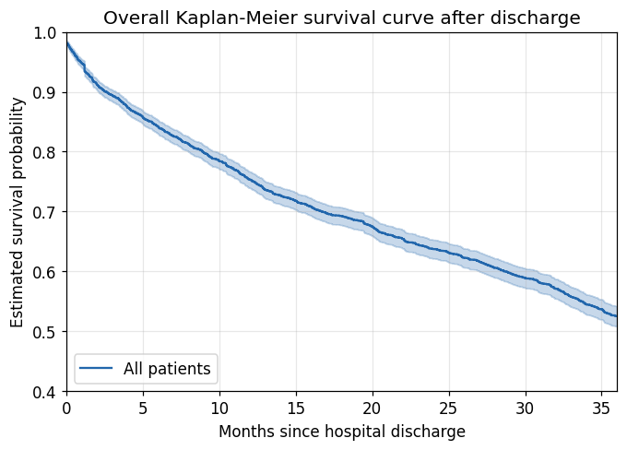
Figure 1. Overall Kaplan–Meier survival curve after hospital discharge, with 95% pointwise confidence band.
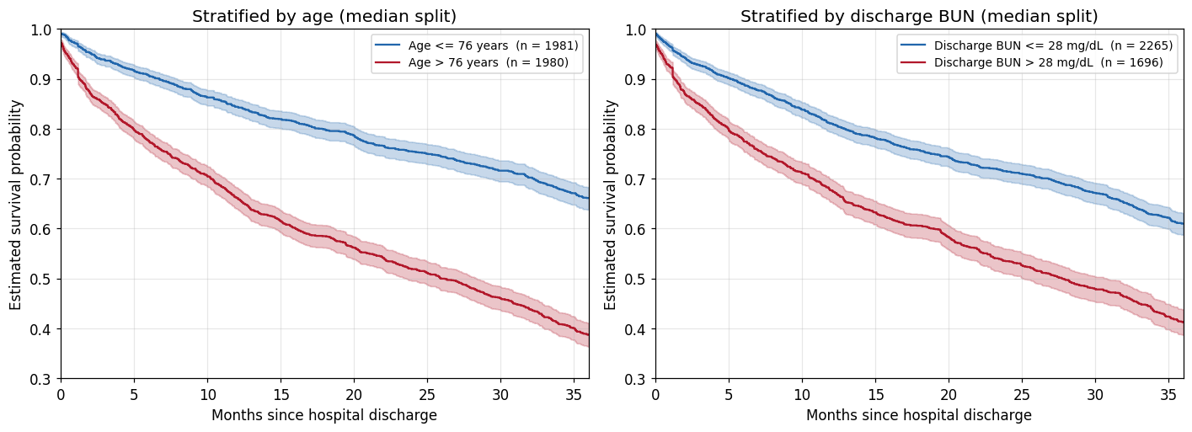
Figure 2. Kaplan–Meier curves stratified at the median of age (left, 76 years) and of discharge BUN (right, 28 mg/dL), with 95% confidence bands.
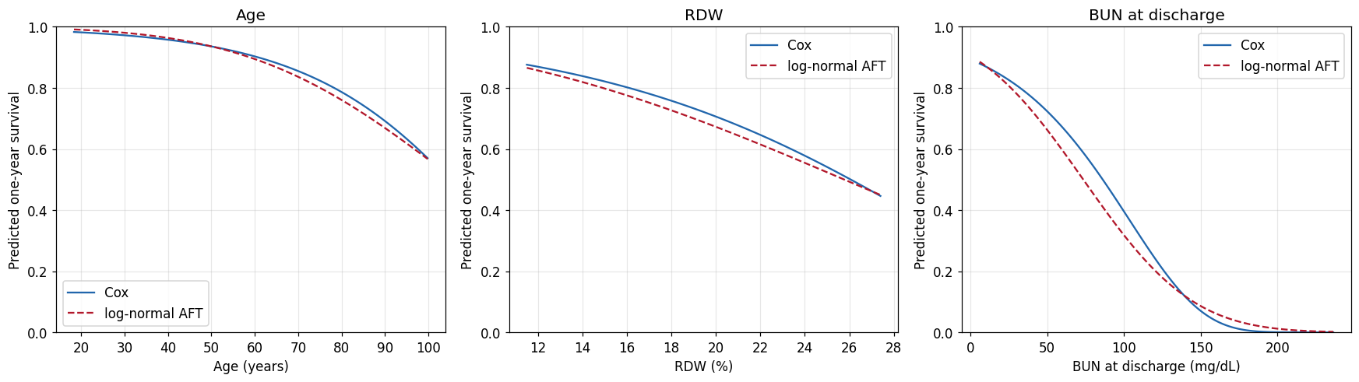
Figure 3. Predicted one-year survival from the PA2 Cox model and the log-normal AFT model, sweeping age, RDW and discharge BUN in turn across the full observed range with the remaining covariates at representative values.
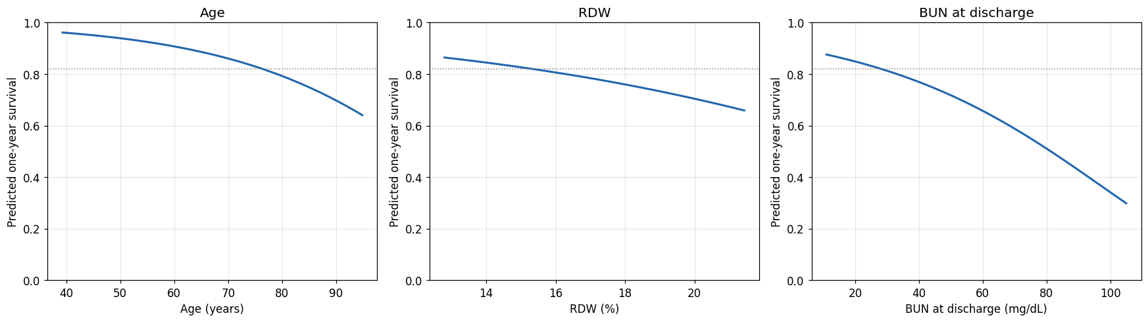
Figure 4. Predicted one-year survival from the Cox model fitted on the training data, as a function of age, RDW and discharge BUN in turn. Remaining covariates are held at their training representative values. The dotted line marks the representative patient's predicted survival of 0.821; each curve crosses it at the covariate's median. Grids run from the 1st to the 99th training percentile.
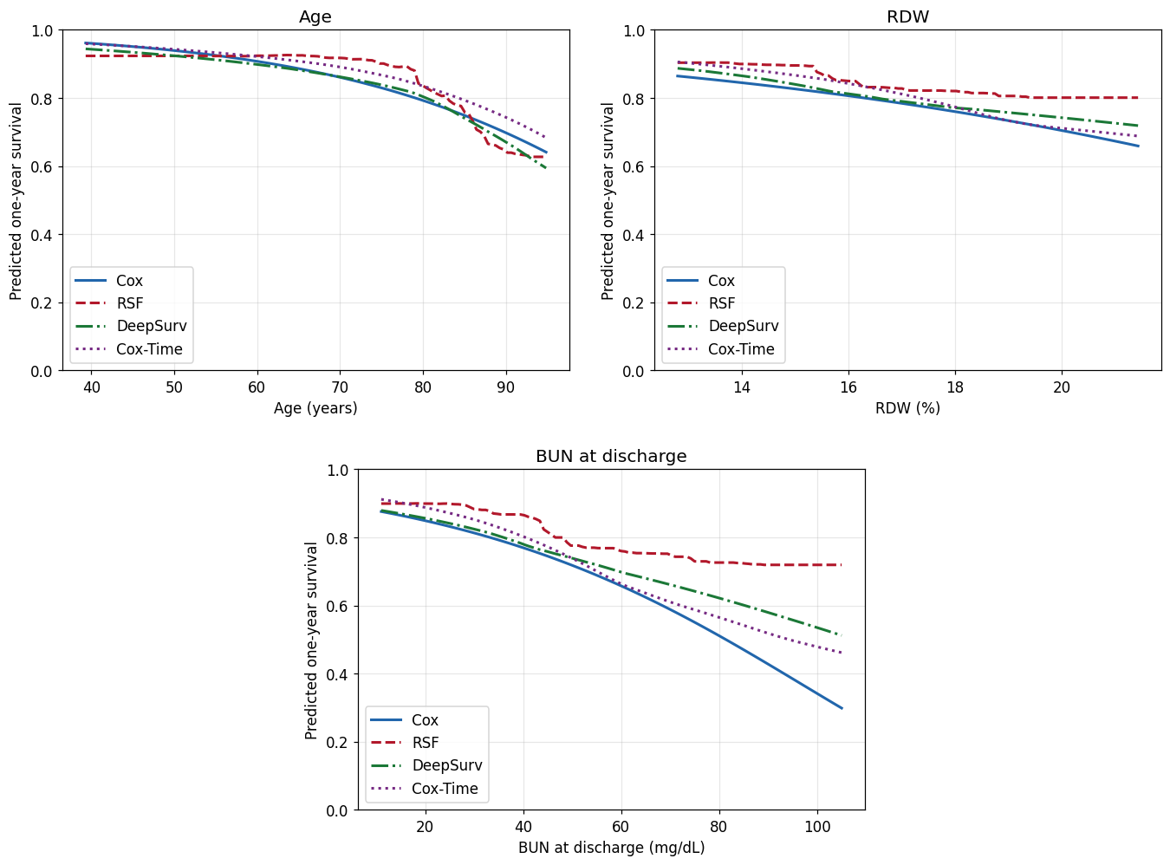
Figure 5. Predicted one-year survival as a function of age (top left), RDW (top right) and discharge BUN (bottom) for the Cox model, the random survival forest, DeepSurv and Cox-Time. All four use identical covariate grids and identical representative values for the remaining covariates.
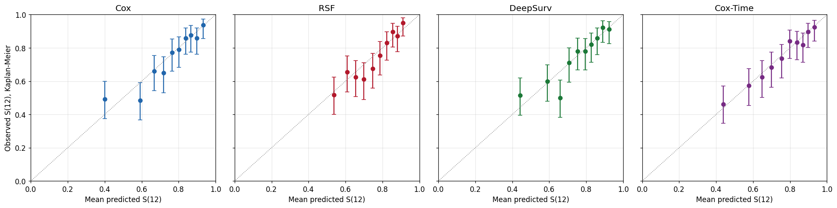
Figure 6. Calibration of the four models on the test set. Test patients are divided into deciles of predicted one-year survival; each point plots mean predicted against the Kaplan–Meier estimate of observed one-year survival in that decile, with 95% confidence intervals. The dotted line is the diagonal.
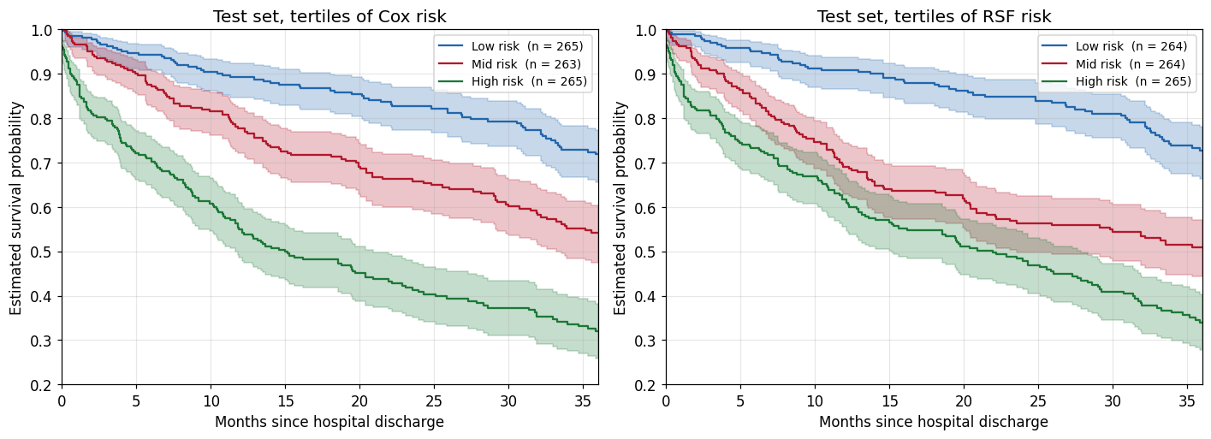
Figure 7. Kaplan–Meier curves for the test set split into tertiles of predicted one-year risk, by the Cox model (left) and by the random survival forest (right), with 95% confidence bands.
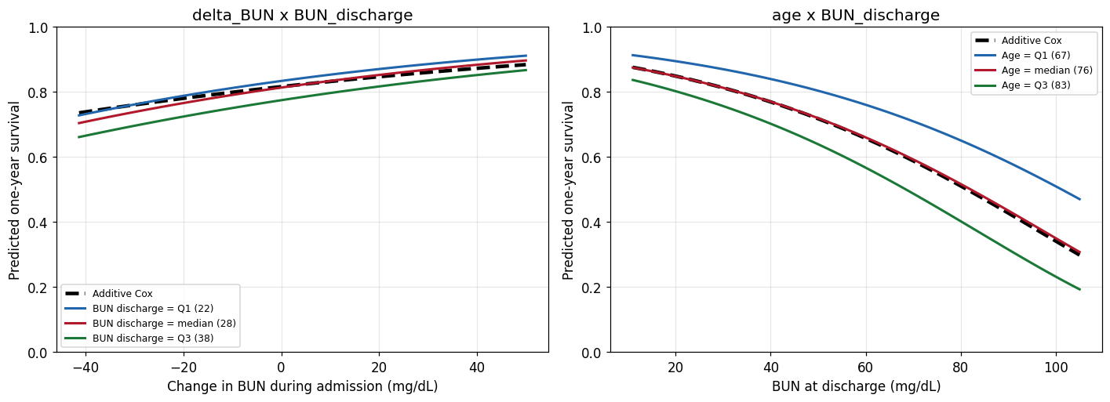
Figure 8. Predicted one-year survival under each interaction model, compared with the additive Cox model (black dashed). Left: as a function of ΔBUN, with discharge BUN at its training Q1, median and Q3. Right: as a function of discharge BUN, with age at its training Q1, median and Q3.
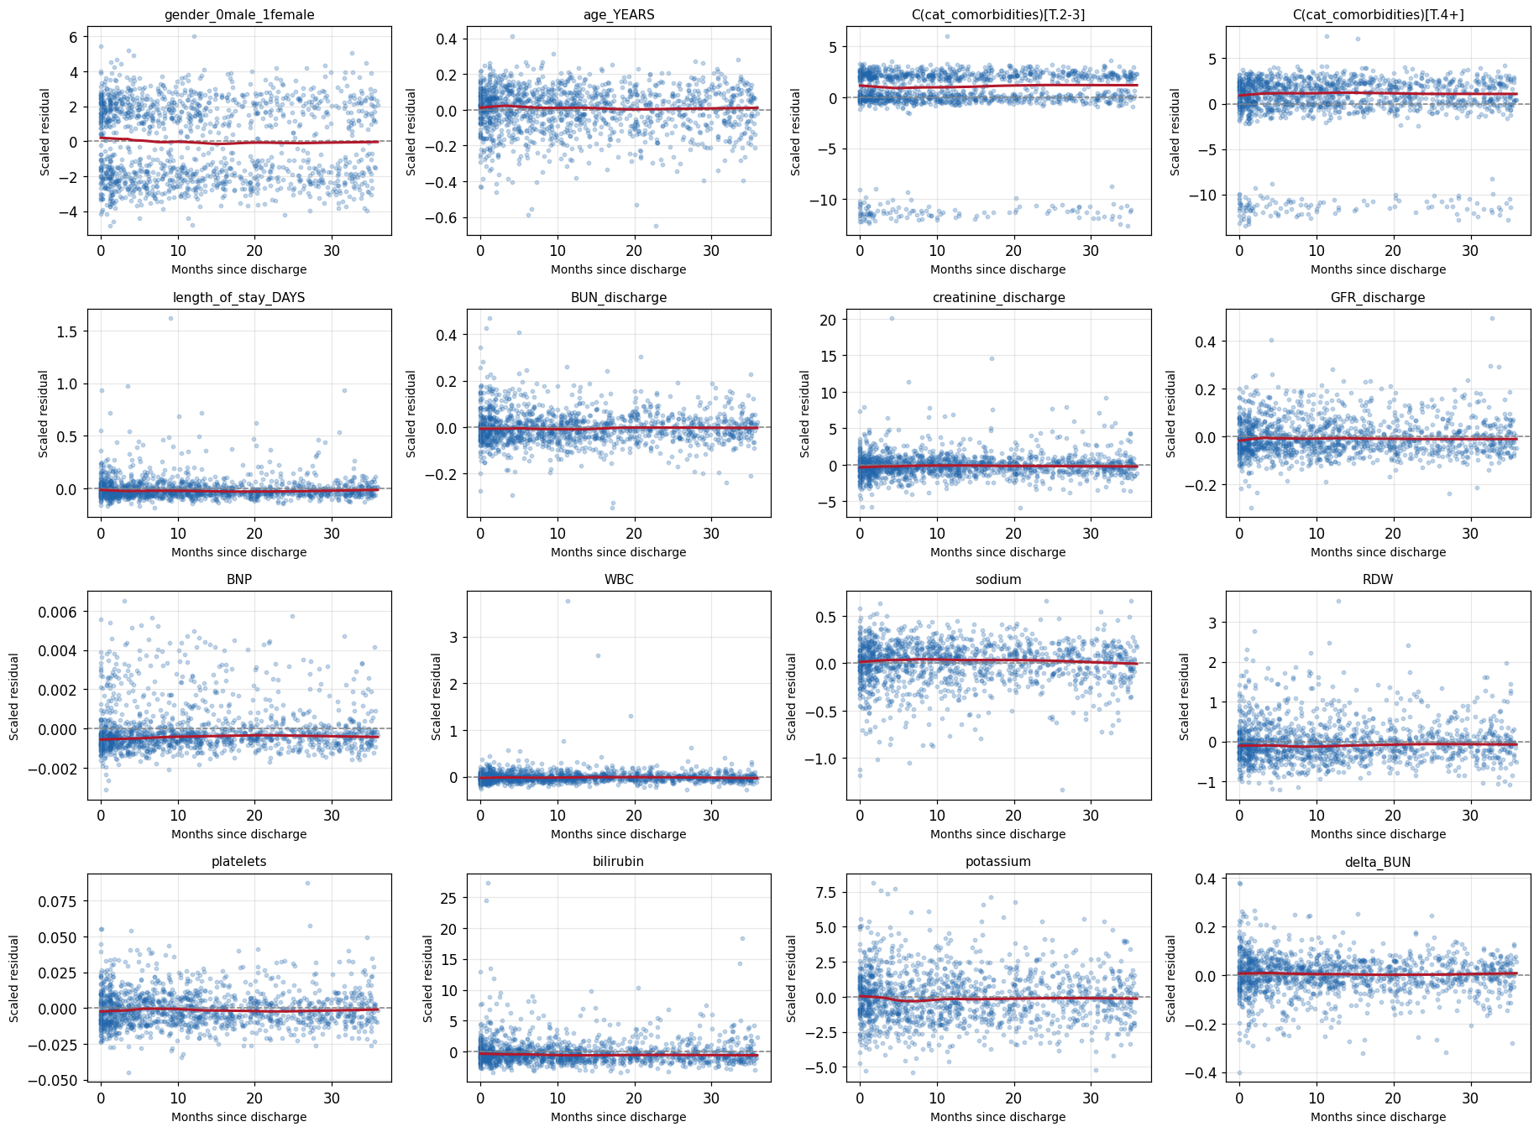
Figure A1. Scaled Schoenfeld residuals against time since discharge for every term in the Cox model refitted on the training data, each with a lowess smoother (red). Flat smoothers are consistent with proportional hazards. The comorbidity burden panels fall into bands rather than a cloud because the variable enters as dummy indicators, which is a feature of the coding and not evidence of a violation.
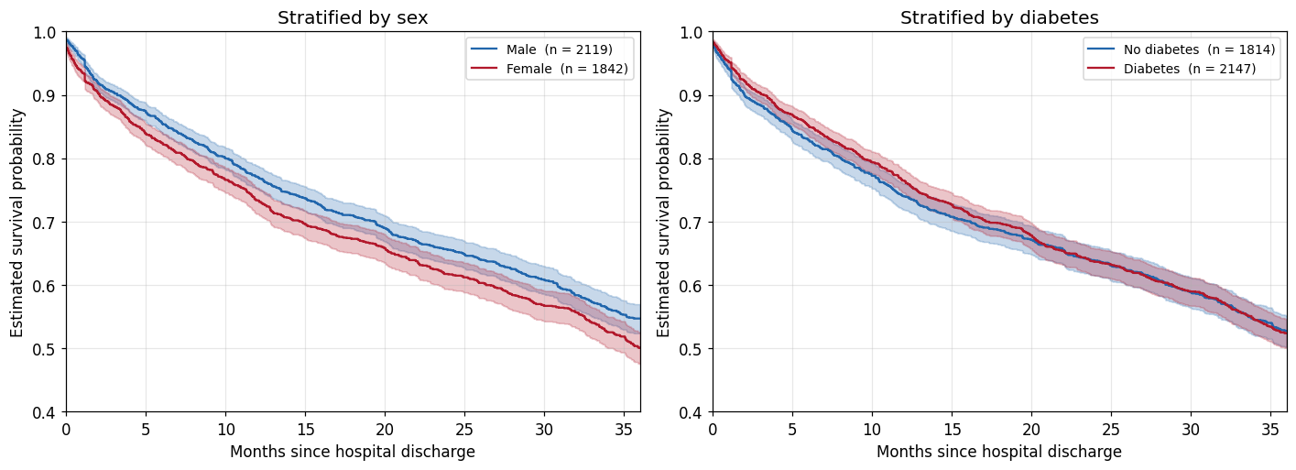
Figure A2. Kaplan–Meier curves stratified by sex (left) and by diabetes (right), as examined in PA1, with 95% confidence bands. Neither variable separates the cohort: one-year survival is 0.770 against 0.733 by sex and 0.740 against 0.764 by diabetes.

Tables
Table 1. Sample size, observed events and the composition of censoring.
 | n | % of cohort
Patients (sample size) | 3,961 | 100.0
Observed deaths (death = 1) | 1,679 | 42.4
Censored observations (death = 0) | 2,282 | 57.6
of which administratively censored at 36 months | 1,473 | 37.2
of which lost to follow-up before 36 months | 809 | 20.4

Table 2. Covariate summary for all 3,961 patients. Continuous variables are given as median [Q1, Q3] and binary variables as n (%).
Covariate | Summary | All patients (n = 3,961)
Demographics
Age (years) | median [Q1, Q3] | 76.18 [66.85, 83.24]
Female sex | n (%) | 1,842 (46.5%)
Comorbidities (as recorded in PA1)
Diabetes | n (%) | 2,147 (54.2%)
Hypertension | n (%) | 3,432 (86.6%)
COPD | n (%) | 405 (10.2%)
Peripheral vascular disease | n (%) | 367 (9.3%)
Chronic kidney disease | n (%) | 805 (20.3%)
Ischaemic heart disease | n (%) | 2,484 (62.7%)
Atrial fibrillation | n (%) | 1,608 (40.6%)
Valvular heart disease | n (%) | 981 (24.8%)
Pulmonary hypertension | n (%) | 737 (18.6%)
Laboratory values on admission
BNP (pg/mL) | median [Q1, Q3] | 778.10 [734.38, 832.40]
BUN (mg/dL) | median [Q1, Q3] | 25.00 [19.00, 37.00]
Creatinine (mg/dL) | median [Q1, Q3] | 1.23 [0.95, 1.70]
GFR (mL/min/1.73 m²) | median [Q1, Q3] | 49.84 [34.64, 67.64]
Laboratory values on discharge
BUN (mg/dL) | median [Q1, Q3] | 28.00 [22.00, 39.00]
Creatinine (mg/dL) | median [Q1, Q3] | 1.23 [1.00, 1.56]
GFR (mL/min/1.73 m²) | median [Q1, Q3] | 50.43 [34.76, 67.63]
Other laboratory values
White blood cells (1000/µL) | median [Q1, Q3] | 8.92 [7.00, 11.42]
Sodium (mEq/L) | median [Q1, Q3] | 138.00 [135.00, 140.00]
Red cell distribution width, RDW (%) | median [Q1, Q3] | 15.30 [14.50, 16.10]
Platelets (1000/µL) | median [Q1, Q3] | 225.00 [180.00, 280.30]
Bilirubin (mg/dL) | median [Q1, Q3] | 0.60 [0.50, 0.72]
Potassium (mEq/L) | median [Q1, Q3] | 4.30 [3.90, 4.60]
Hospitalisation
Length of stay (days) | median [Q1, Q3] | 5.13 [3.08, 8.34]

Table 3. The Cox model selected in PA2, fitted to the full dataset (n = 3,961), ordered by p-value. HR = hazard ratio.
Covariate | HR | 95% CI | p
Age (years) | 1.0438 | 1.0382 – 1.0495 | < 0.001
BUN, discharge | 1.0213 | 1.0176 – 1.0249 | < 0.001
Sodium | 0.9728 | 0.9627 – 0.9831 | < 0.001
BNP | 1.0002 | 1.0001 – 1.0002 | < 0.001
ΔBUN | 0.9903 | 0.9867 – 0.9938 | < 0.001
RDW | 1.1204 | 1.0903 – 1.1514 | < 0.001
Length of stay | 1.0094 | 1.0037 – 1.0151 | 0.001
Bilirubin | 1.1208 | 1.0068 – 1.2477 | 0.037
Potassium | 0.9141 | 0.8397 – 0.9951 | 0.038
Platelets | 1.0004 | 0.9999 – 1.0009 | 0.100
Creatinine, discharge | 0.9376 | 0.8622 – 1.0195 | 0.132
Comorbidity burden 2–3 | 0.8885 | 0.7431 – 1.0624 | 0.195
White blood cells | 1.0028 | 0.9958 – 1.0098 | 0.436
Female sex | 0.9693 | 0.8732 – 1.0759 | 0.558
GFR, discharge | 1.0010 | 0.9975 – 1.0045 | 0.585
Comorbidity burden 4+ | 0.9882 | 0.8243 – 1.1846 | 0.898

Table 4. The 80/20 stratified train–test split at seed 42.
Set | n | Events | Event rate | Deaths by 12 months
Training | 3,168 | 1,343 | 0.424 | 748
Test | 793 | 336 | 0.424 | 199

Table 5. Selected configuration for each model with its cross-validated IBS over the first year (mean and standard error across the five folds). The Cox row is a reference scored on the same folds; these scores selected the configurations and are not performance estimates.
Model | Selected configuration | CV IBS | SE
Cox (reference) | no tuning | 0.1097 | 0.0030
RSF | 500 trees, min leaf = 50, max features = 4 | 0.1116 | 0.0033
DeepSurv | hidden [16], dropout 0.4, lr 0.001, 108 epochs | 0.1093 | 0.0027
Cox-Time | hidden [16], dropout 0.4, lr 0.01, 24 epochs | 0.1113 | 0.0033

Table 6. The selected Cox model refitted on the training data (n = 3,168, 1,343 events), with the full-data estimates of Table 3 for comparison. Rows are ordered by the full-data p-value.
Covariate | HR (train) | 95% CI (train) | p (train) | HR (full) | p (full)
Age (years) | 1.0447 | 1.0384 – 1.0511 | < 0.001 | 1.0438 | < 0.001
BUN, discharge | 1.0238 | 1.0197 – 1.0279 | < 0.001 | 1.0213 | < 0.001
RDW | 1.1295 | 1.0963 – 1.1638 | < 0.001 | 1.1204 | < 0.001
ΔBUN | 0.9900 | 0.9861 – 0.9940 | < 0.001 | 0.9903 | < 0.001
BNP | 1.0002 | 1.0001 – 1.0002 | < 0.001 | 1.0002 | < 0.001
Sodium | 0.9726 | 0.9611 – 0.9843 | < 0.001 | 0.9728 | < 0.001
Length of stay | 1.0083 | 1.0020 – 1.0146 | 0.010 | 1.0094 | 0.001
Bilirubin | 1.0988 | 0.9738 – 1.2400 | 0.126 | 1.1208 | 0.037
Potassium | 0.9196 | 0.8376 – 1.0096 | 0.078 | 0.9141 | 0.038
Platelets | 1.0005 | 0.9998 – 1.0012 | 0.147 | 1.0004 | 0.100
Creatinine, discharge | 0.9172 | 0.8345 – 1.0080 | 0.073 | 0.9376 | 0.132
Comorbidity burden 2–3 | 0.8754 | 0.7181 – 1.0672 | 0.188 | 0.8885 | 0.195
White blood cells | 1.0001 | 0.9918 – 1.0085 | 0.976 | 1.0028 | 0.436
Female sex | 0.9809 | 0.8720 – 1.1035 | 0.749 | 0.9693 | 0.558
GFR, discharge | 1.0014 | 0.9975 – 1.0053 | 0.492 | 1.0010 | 0.585
Comorbidity burden 4+ | 0.9835 | 0.8046 – 1.2021 | 0.871 | 0.9882 | 0.898

Table 7. Schoenfeld residual test for proportional hazards on a rank transform of time, for the refitted model on the training data and the PA2 model on the full data. Rows are ordered by the training p-value.
Covariate | Statistic (train) | p (train) | Statistic (full) | p (full)
Comorbidity burden 4+ | 5.366 | 0.021 | 2.700 | 0.100
Comorbidity burden 2–3 | 5.060 | 0.025 | 1.388 | 0.239
Bilirubin | 4.452 | 0.035 | 2.454 | 0.117
Creatinine, discharge | 3.159 | 0.076 | 2.740 | 0.098
BUN, discharge | 2.465 | 0.116 | 4.392 | 0.036
Length of stay | 2.217 | 0.137 | 3.911 | 0.048
ΔBUN | 2.141 | 0.143 | 0.625 | 0.429
Female sex | 1.709 | 0.191 | 1.269 | 0.260
GFR, discharge | 1.031 | 0.310 | 0.828 | 0.363
Potassium | 0.963 | 0.326 | 0.601 | 0.438
Age (years) | 0.452 | 0.501 | 1.064 | 0.302
Sodium | 0.289 | 0.591 | 1.643 | 0.200
White blood cells | 0.237 | 0.627 | 0.121 | 0.728
BNP | 0.208 | 0.649 | 0.087 | 0.768
Platelets | 0.004 | 0.951 | 0.225 | 0.636
RDW | 0.000 | 0.991 | 0.025 | 0.875

Table 8. Predicted one-year survival at the ends of each plotted grid and across each covariate's interquartile range, from the Cox model fitted on the training data.
Covariate | Grid (1st–99th pct) | S at grid low | S at grid high | Drop over grid | Drop over IQR
Age (years) | 39.3 – 94.8 | 0.962 | 0.641 | 0.321 | 0.110
RDW (%) | 12.8 – 21.4 | 0.864 | 0.659 | 0.205 | 0.034
BUN, discharge (mg/dL) | 11 – 105 | 0.876 | 0.298 | 0.577 | 0.064

Table 9. Predicted one-year survival at the ends of each plotted grid and across each covariate's interquartile range, for all four models. The Cox rows reproduce Table 8 exactly, confirming that all four are evaluated on the same grids and the same representative patient.
Covariate | Model | S at grid low | S at grid high | Drop over grid | Drop over IQR
Age (years) | Cox | 0.962 | 0.641 | 0.321 | 0.110
 | RSF | 0.924 | 0.627 | 0.297 | 0.118
 | DeepSurv | 0.944 | 0.594 | 0.350 | 0.108
 | Cox-Time | 0.959 | 0.683 | 0.276 | 0.092
RDW (%) | Cox | 0.864 | 0.659 | 0.205 | 0.034
 | RSF | 0.904 | 0.801 | 0.103 | 0.057
 | DeepSurv | 0.887 | 0.719 | 0.168 | 0.045
 | Cox-Time | 0.906 | 0.688 | 0.218 | 0.040
BUN, discharge | Cox | 0.876 | 0.298 | 0.577 | 0.064
 | RSF | 0.899 | 0.719 | 0.180 | 0.032
 | DeepSurv | 0.879 | 0.512 | 0.367 | 0.060
 | Cox-Time | 0.912 | 0.462 | 0.450 | 0.068

Table 10 appears in Section 6.4.
Table 11a. Spearman rank correlation between the four models' predicted one-year risk on the test set.
 | Cox | RSF | DeepSurv | Cox-Time
Cox | 1.000 | 0.884 | 0.974 | 0.971
RSF | 0.884 | 1.000 | 0.905 | 0.884
DeepSurv | 0.974 | 0.905 | 1.000 | 0.971
Cox-Time | 0.971 | 0.884 | 0.971 | 1.000

Table 11b. Overlap between the top-risk quintiles of each pair of models: 159 test patients per model.
Model A | Model B | Shared of 159 | Shared % | Jaccard
Cox | RSF | 113 | 71.1 | 0.551
Cox | DeepSurv | 140 | 88.1 | 0.787
Cox | Cox-Time | 142 | 89.3 | 0.807
RSF | DeepSurv | 124 | 78.0 | 0.639
RSF | Cox-Time | 114 | 71.7 | 0.559
DeepSurv | Cox-Time | 139 | 87.4 | 0.777

Table 12. Test-set discrimination and prediction error within subgroups defined by the training medians of discharge BUN (28 mg/dL) and age (76 years). n is the number of test patients, "deaths" the number dying within 12 months.
Subgroup | Measure | n (deaths) | Cox | RSF | DeepSurv | Cox-Time
BUN ≤ 28 mg/dL | Uno's C | 430 (81) | 0.7140 | 0.6946 | 0.7026 | 0.7013
 | IBS | 430 (81) | 0.0901 | 0.0933 | 0.0911 | 0.0904
BUN > 28 mg/dL | Uno's C | 363 (118) | 0.6361 | 0.6173 | 0.6339 | 0.6286
 | IBS | 363 (118) | 0.1446 | 0.1449 | 0.1437 | 0.1437
Age ≤ 76 years | Uno's C | 406 (62) | 0.6663 | 0.7010 | 0.6740 | 0.6735
 | IBS | 406 (62) | 0.0787 | 0.0783 | 0.0787 | 0.0783
Age > 76 years | Uno's C | 387 (137) | 0.6172 | 0.5800 | 0.6075 | 0.6150
 | IBS | 387 (137) | 0.1532 | 0.1574 | 0.1535 | 0.1531

Table 13. Likelihood-ratio and Wald tests for the two pre-specified interactions, each added as a single term to the refitted Cox model and fitted on the training data. The likelihood-ratio statistic has 1 degree of freedom; the Bonferroni-corrected threshold for two pre-specified tests is 0.025.
Interaction term | HR | 95% CI | Wald p | LR statistic | LR p
BUN, discharge × ΔBUN | 1.0001 | 1.0000 – 1.0002 | 0.012 | 5.854 | 0.016
Age × BUN, discharge | 1.0001 | 0.9998 – 1.0003 | 0.592 | 0.288 | 0.592

Table 14. Predictive performance of the additive Cox model and each interaction model: test-set Uno's C at τ = 12 months, test-set IBS over the first year, and cross-validated IBS on the five training folds (fold-to-fold standard error 0.0030 throughout).
Model | Uno's C (test) | IBS (test) | CV IBS (train)
Cox (additive) | 0.6959 | 0.1150 | 0.1097
+ BUN, discharge × ΔBUN | 0.6933 | 0.1152 | 0.1094
+ Age × BUN, discharge | 0.6955 | 0.1151 | 0.1097

